REVIEWING AND SUBMITTING YOUR TIMESHEET VIA DESKTOP/LAPTOP

All employees are responsible for reviewing their weekly timesheet for accuracy and then submitting it for supervisor approval.

To do so from a desktop or laptop, login to Kronos
From the Home tab, click on My Timesheet

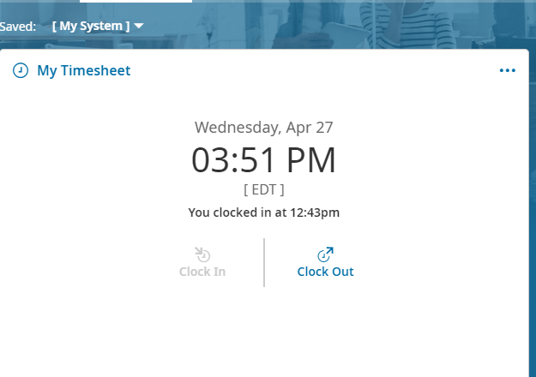

Your timesheet should be similar to this. The days will be pre-populated based on your work schedule.

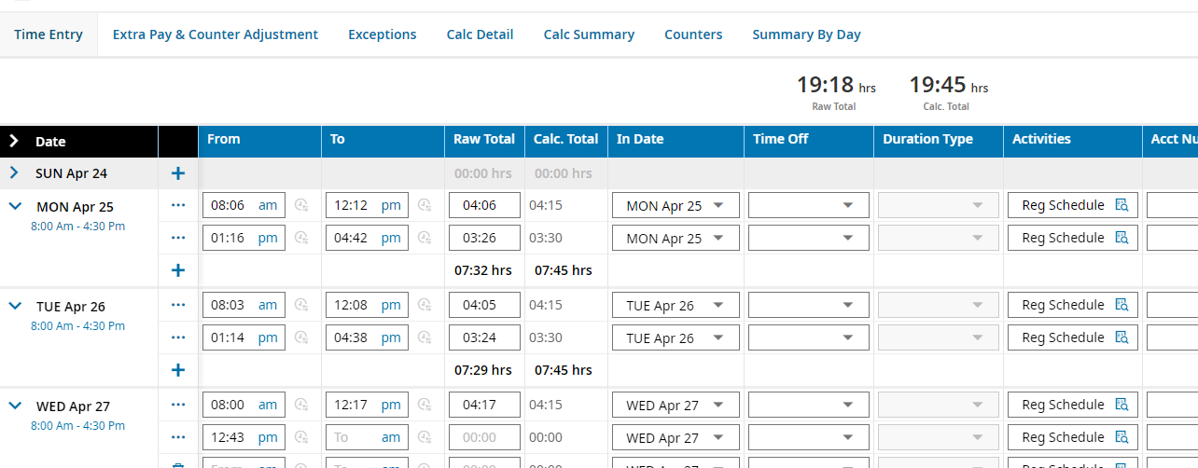

Your scheduled work times are shown here. If this is incorrect, please contact Payroll at payroll@wtps.org

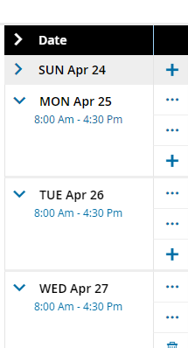
Each time you clock in/out, your time is captured and shown here.

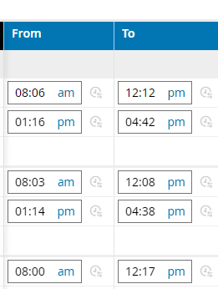

How your time is logged is shown under “Activities”

*Note that additional time, if applicable, is reflected as such and that your activity may differ depending on your specific approval (eg: 6th period stipend, beeper, banquet time, etc). Refer to instructions on clocking in/out when working outside your normal work schedule.

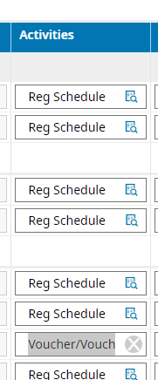

All additional time MUST include an account number (if known) and job description. If you do not know your account number, your supervisor should enter it for you. Your description should be as detailed as possible. Some examples of your description might be:

Subbed for John Smith
Academic Recovery
Class Coverage for 4th Pd Chemistry
Math Club
Student #123456 (for Homebound)
10th grade Algebra II (for 6th period stipend)

Timesheets submitted to Payroll without account numbers and job descriptions for additional time will be rejected.

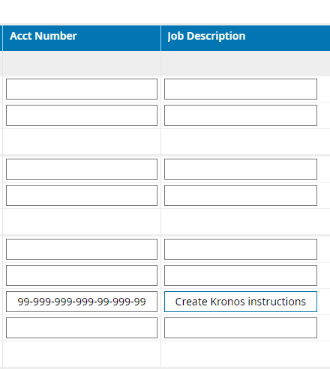

As you review your timesheet, you might find that you missed clocking in or out at some point during the week. Due to the missing information, no credit was given for those hours and that would need to be corrected.

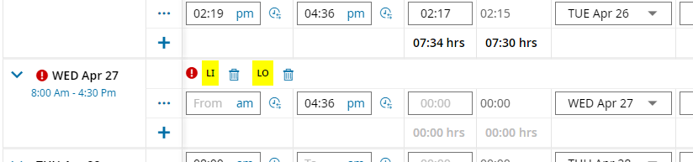

To request a change to the timesheet, click on the Change Request button

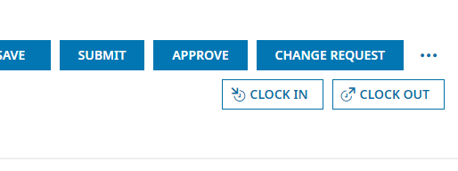

Click on the drop-down arrow to open the selection box

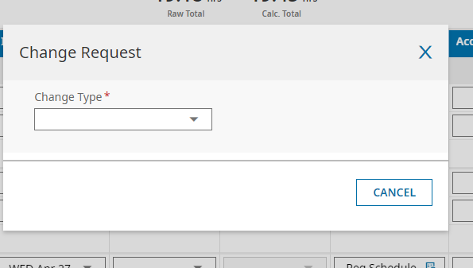

You can see that there are multiple options which will enable you to correct your timesheet for proper payroll calculation. In this example, the employee forgot to clock in so we’re going to select Add Punch In.

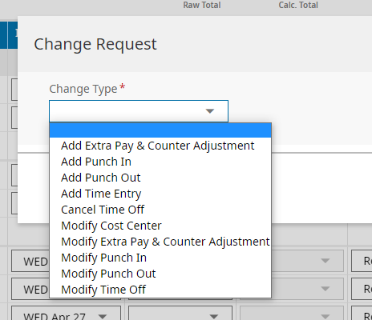

Next, click on the calendar icon to select the date you need to correct. Please note that you can only submit one correction requestion at a time.

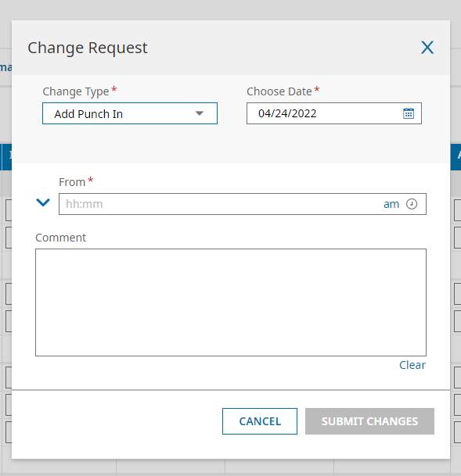

In our example, the employee missed clocking in on April 27th. Click on that day to select it.

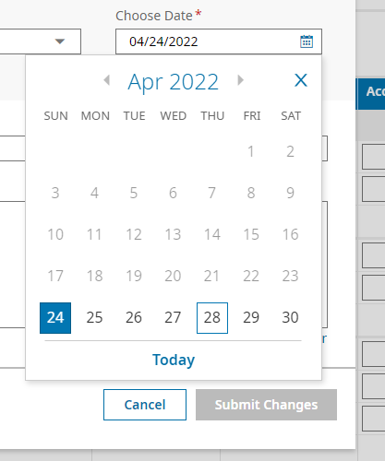

Your date is now reflected in the Choose Date box.
Click in the From* box and enter the time you reported to work.

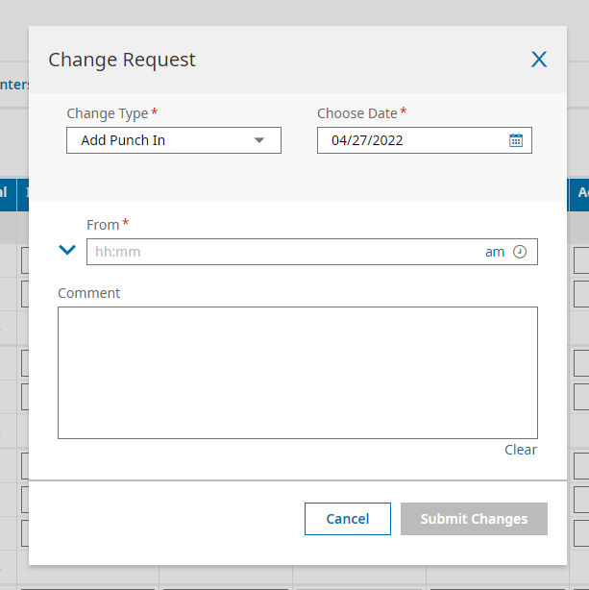

Then click on the “am” to toggle from am to pm if necessary.

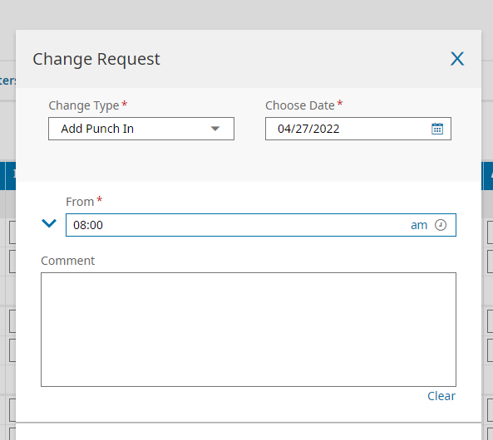

Next, you need to include a comment regarding the need for the correction. In this example, the employee forgot to clock in that day.

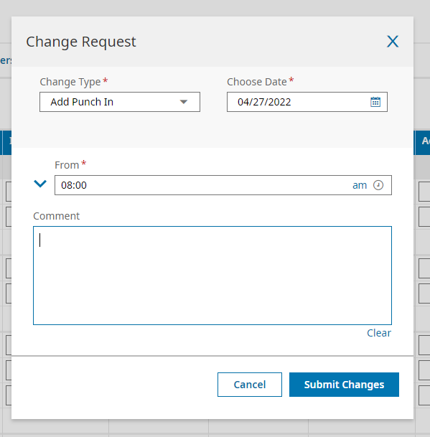

Review your request and if correct, click on the Submit Changes button.

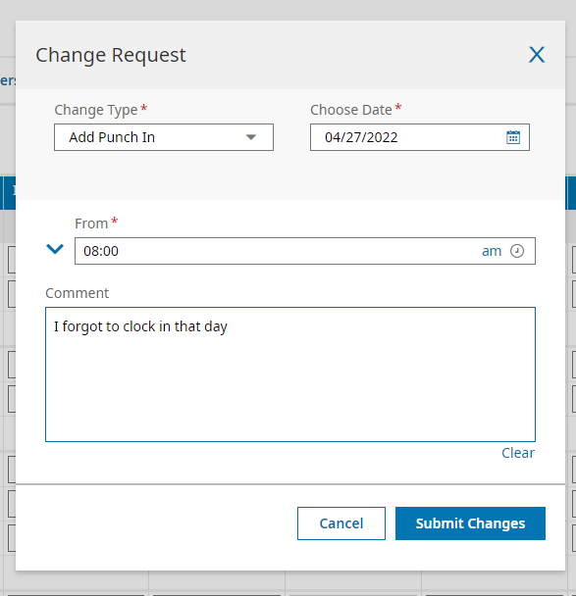

You will get a confirmation that your request was submitted to your supervisor. Click OK.

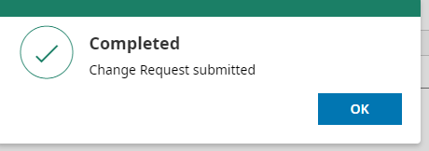

Once your supervisor has had time to process your request, you will receive an email advising whether your request was approved or denied along with a comment/reason for the decision. If approved, the correction will be made in your timesheet.

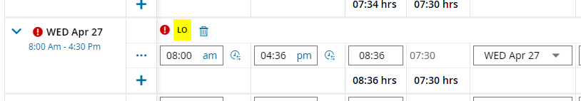

Repeat the process for any other corrections required.

When your timesheet is correct, click on the Submit button

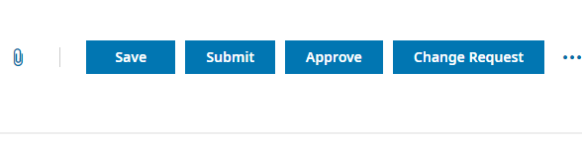

You can choose to leave a Comment if desired, otherwise click on the Submit button

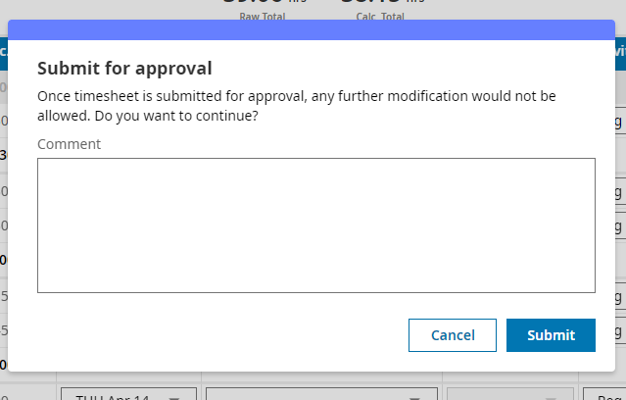
Congratulations! Your timesheet has been submitted to your supervisor for approval. Click on the OK button.

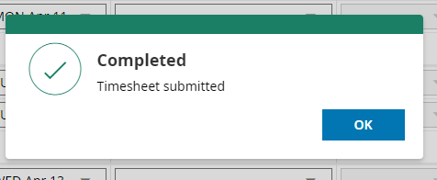

The timesheet now reflects a Submitted status.

